Practical 1- To perform foot printing using google hacking commands.

1. Basic Search
   1. Find pages containing SIESCOMS and MCA.

Command: SIESCOMS MCA

Output:



* 1. Find pages containing Paints saffron OR green OR White.

Command: Paints saffron OR green OR white

Output:

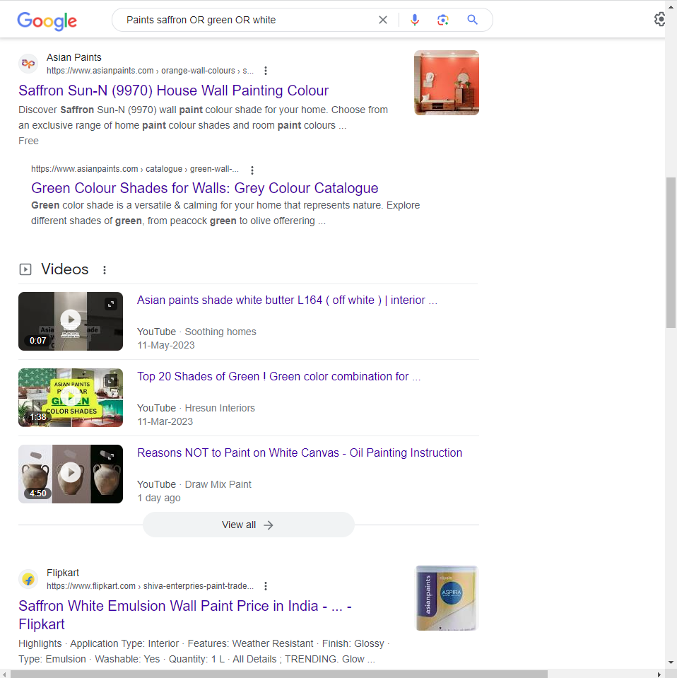

* 1. Find the exact phrase ‘City of Joy’

Command: ‘City of Joy’

Output:

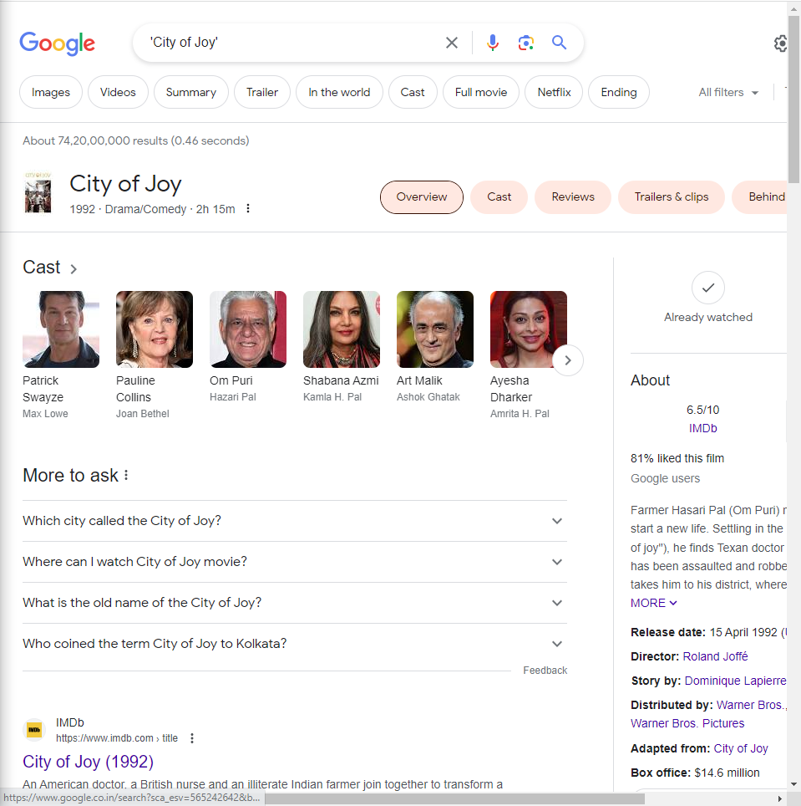

* 1. Find pages that have Ethical but not Hacking.

Command: Ethical –Hacking

Output:

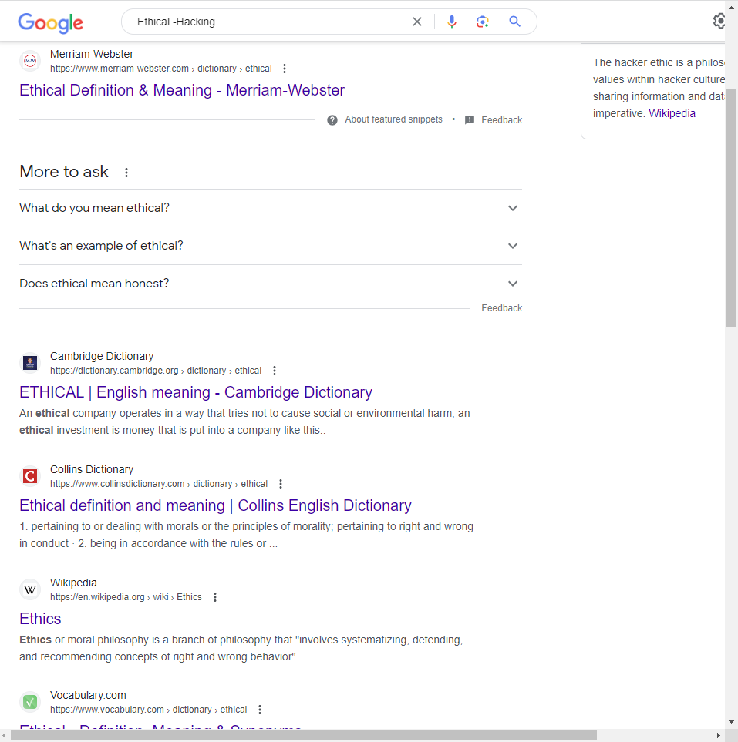

* 1. Display glossary about cyber law.

Command: cyber law ~glossary

Output:

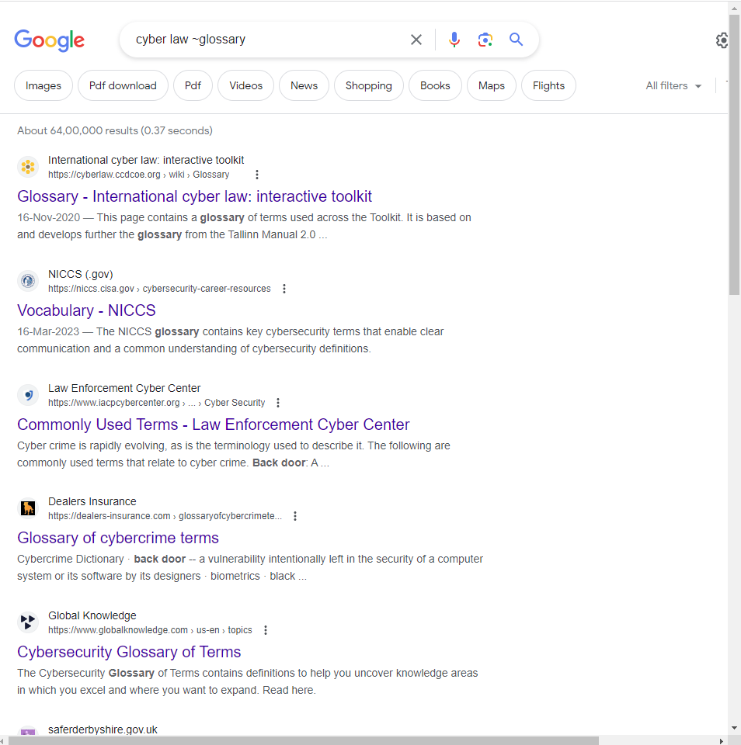

* 1. Display all forms of the term Sum-of-Numbers.

Command: Sum of Numbers

Output:

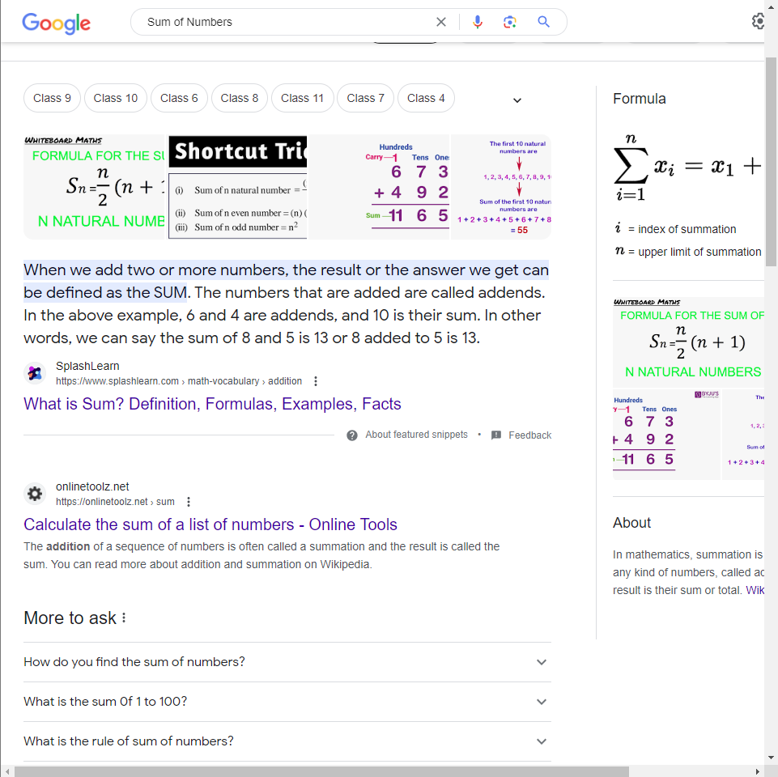

* 1. Display definition of terrorism.

Command: define: terrorism

Output:

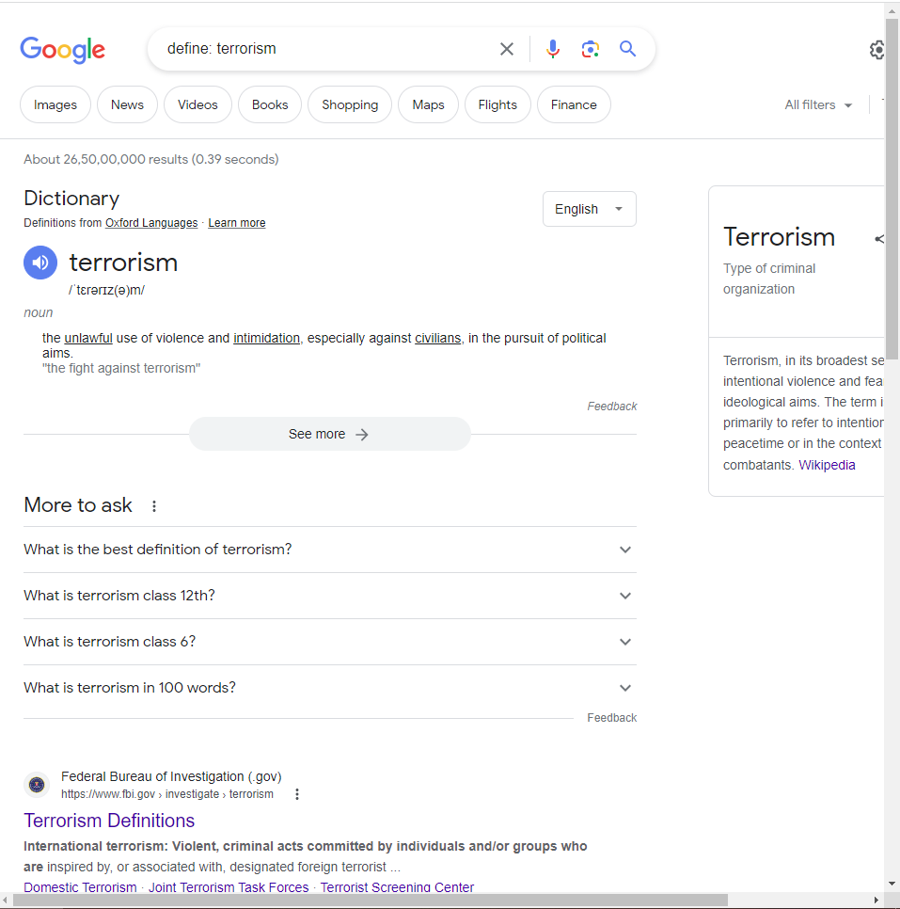

1. Calculator:
   1. Calculate 105-100\*20.

Command 105-100\*20

Output:

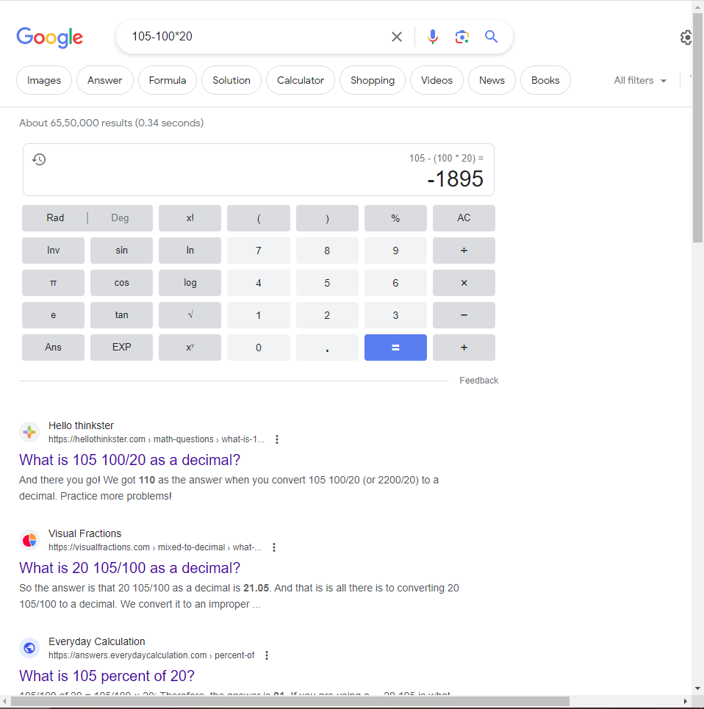

* 1. Find out 35% of 68.

Command: 35% of 68

Output:

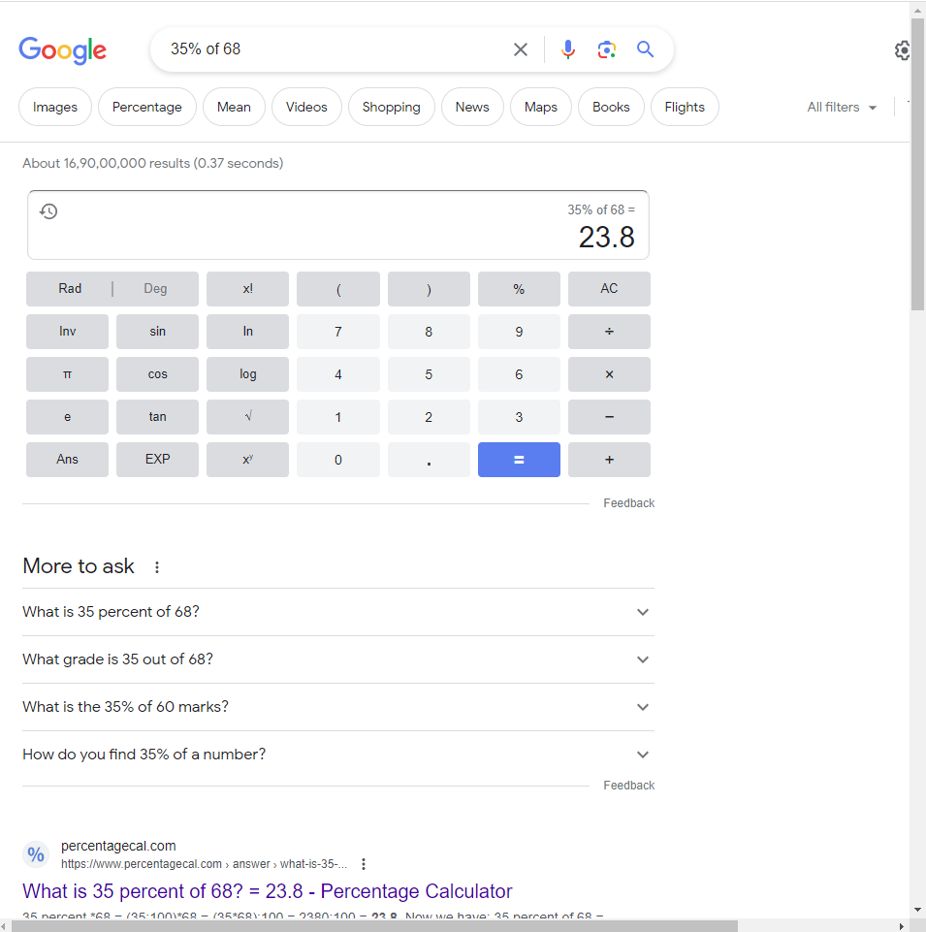

* 1. Convert 100 meters to feet.

Command: 100 meters to feet

Output:

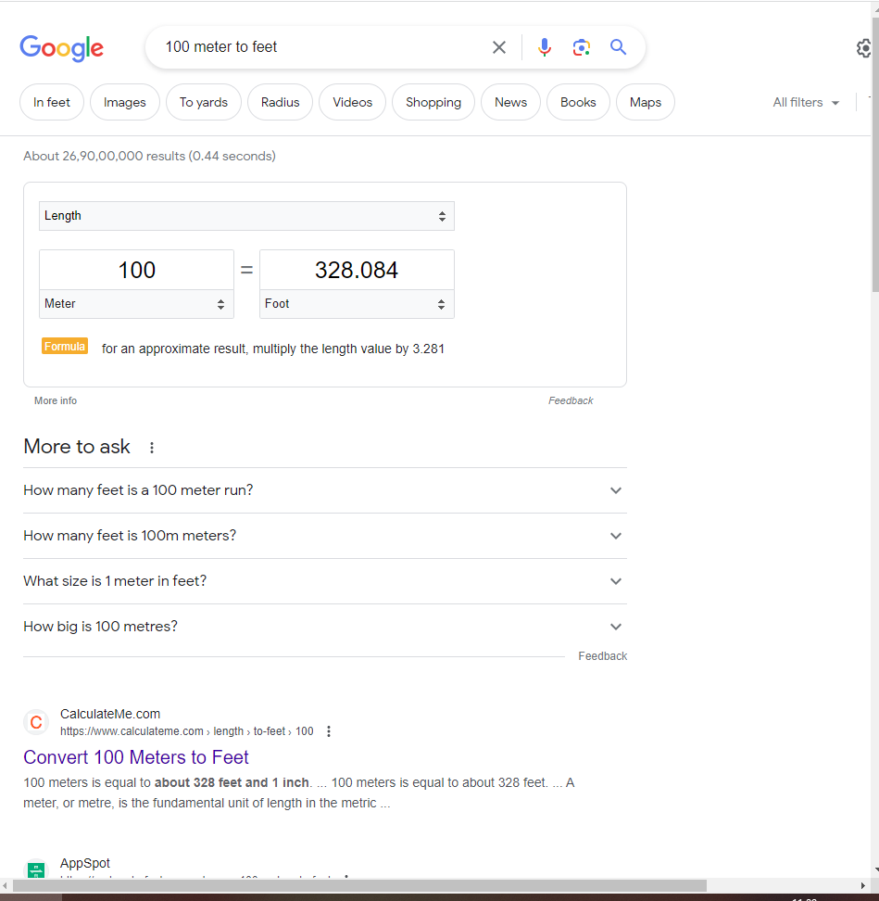

1. Restrictive search:
   1. Book flights from Mum to Del.

Command: Mum Del

Output:

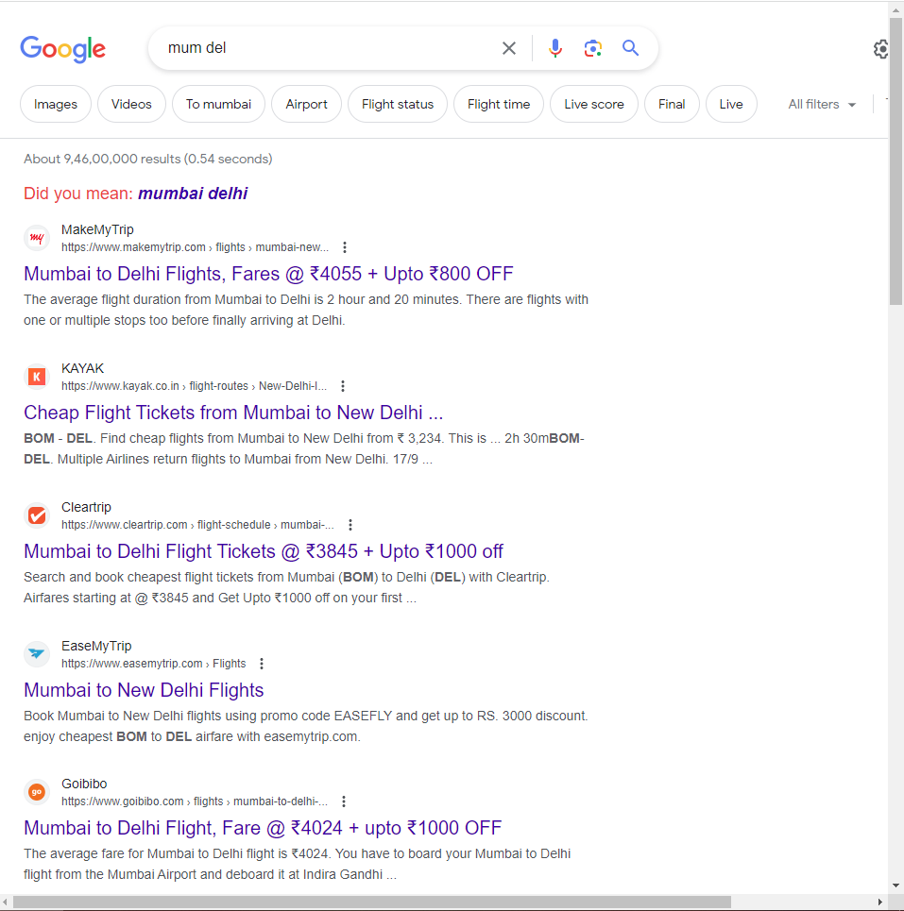

* 1. Search for information on Diwali gathered by the Indian Govt site -india.gov.in.

Command: Diwali site:india.gov.in

Output:

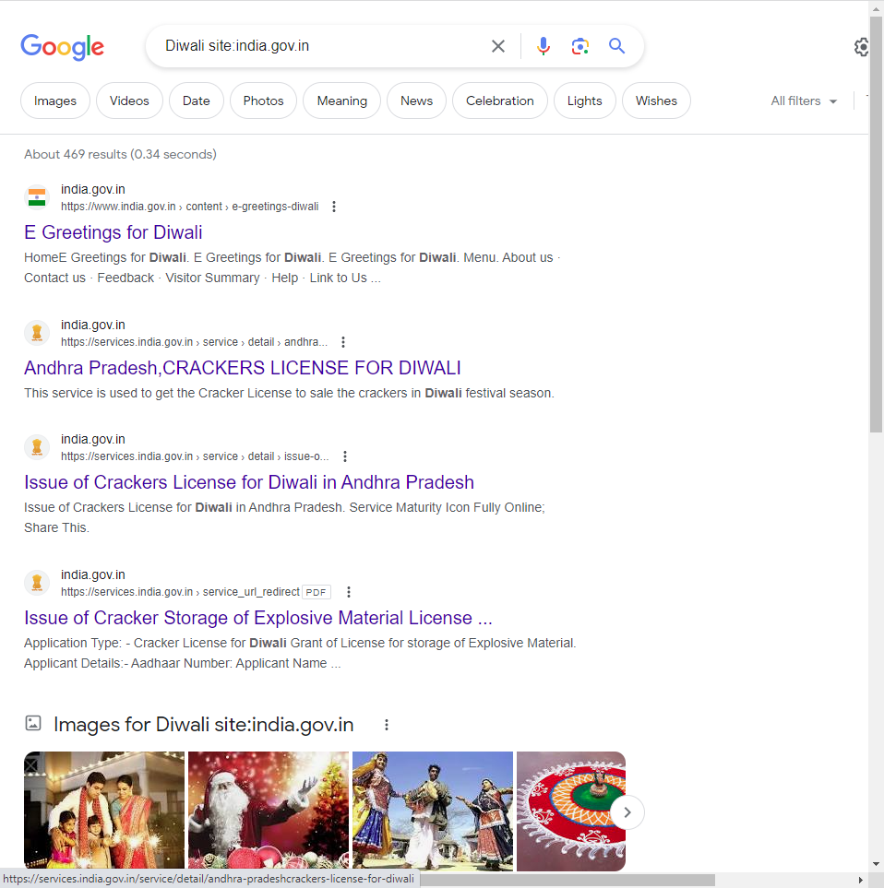

* 1. Search for Bill Gates articles mentioning pirates written in 2010-2020.

Command: Bill Gates pirates 2010..2020

Output:

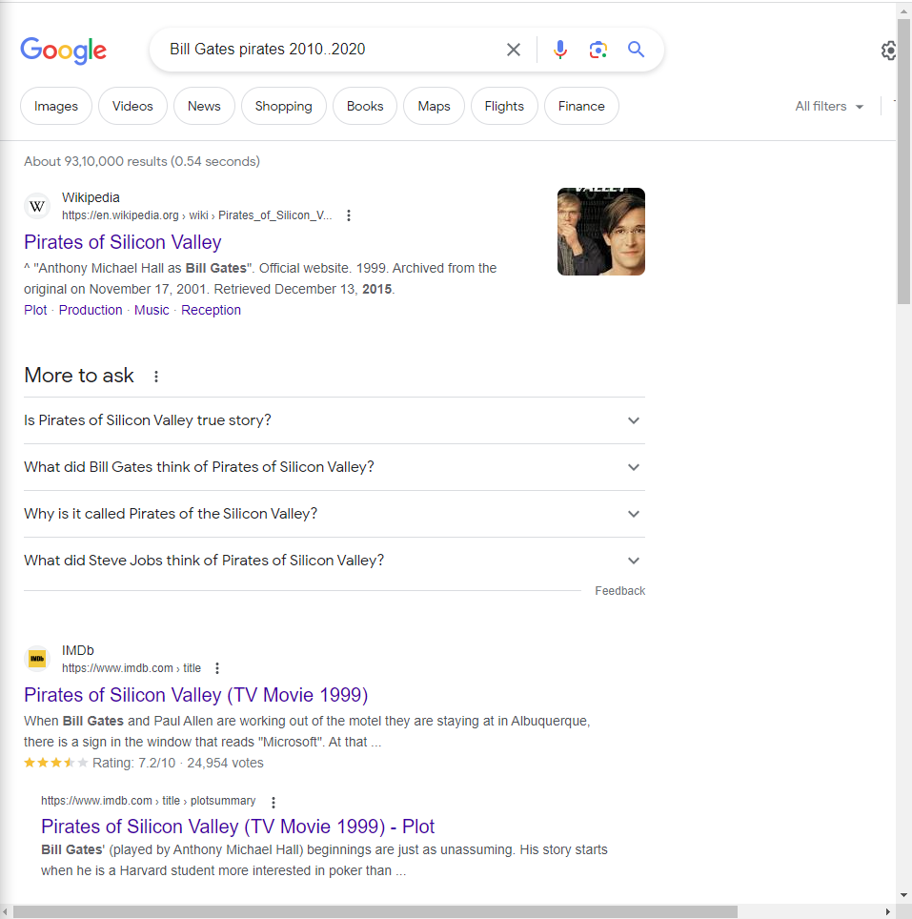

* 1. Find the Form 16: ITR in PDF format.

Command: Form 16 ITR:pdf

Output:

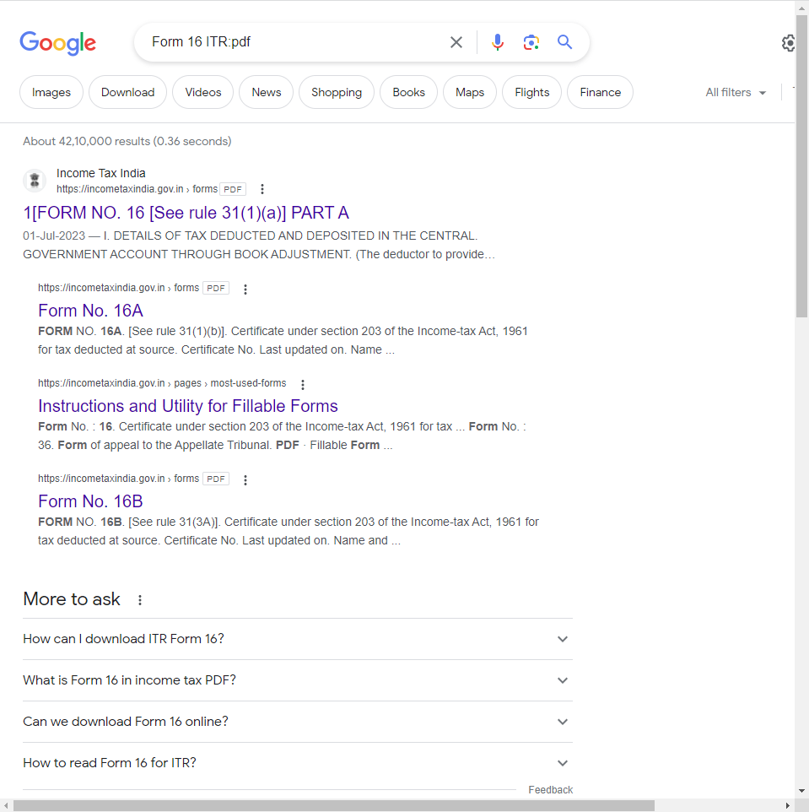

* 1. Find pages that link to amazon.in website.

Command: link:amazon.in

Output:

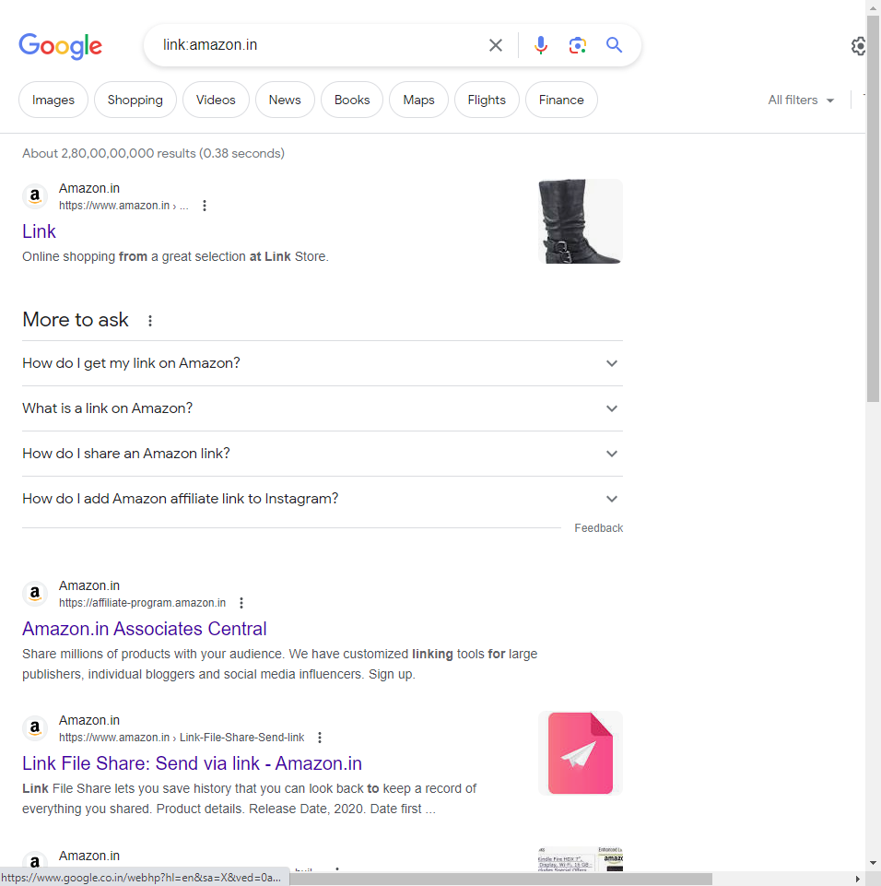

1. Specialized Information Queries
   1. Show Chanakya book-related information .

Command: info: book chanakya

Output:

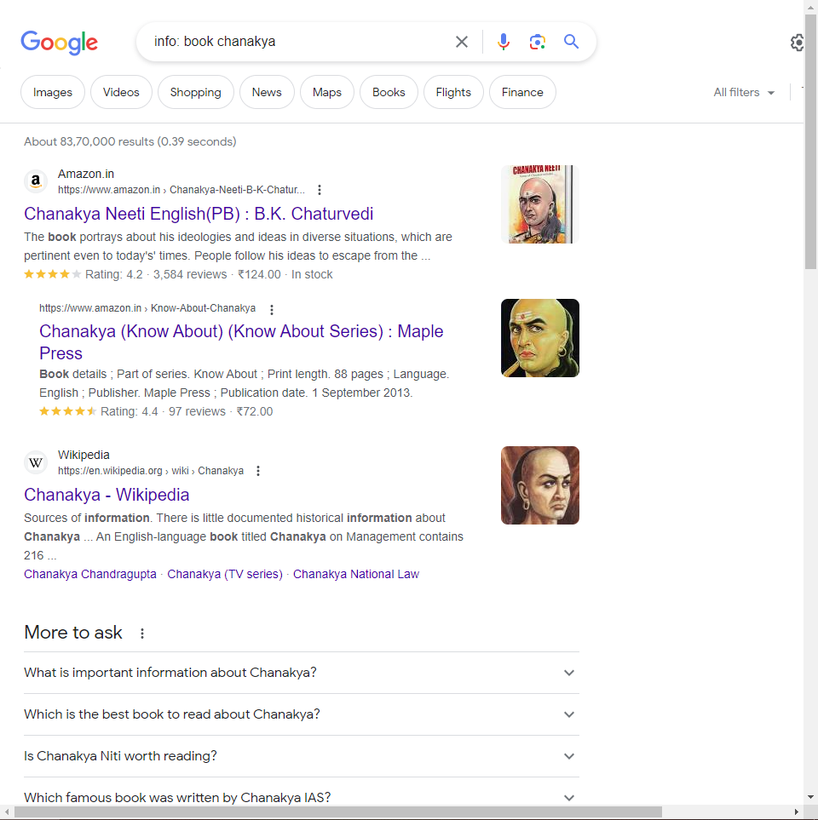

* 1. Define anarchy what is monopoly
  2. Search for information about Hacker movie.

Command: movie: Hacker

Output:

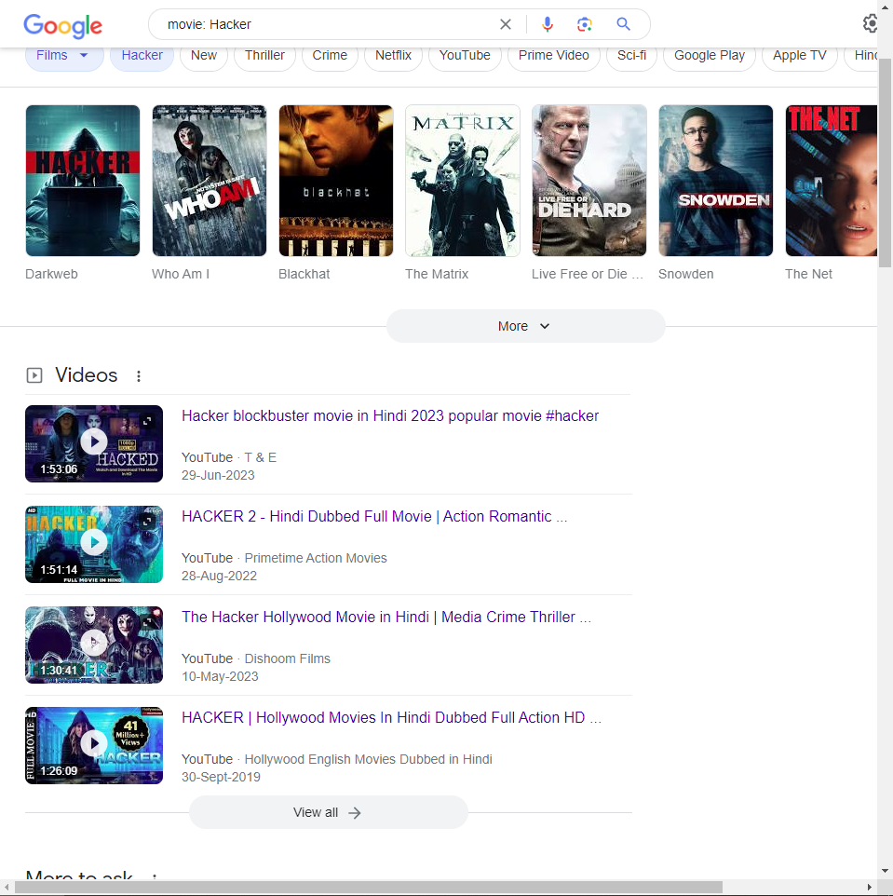

* 1. Find TCS current stock price.

Command: stock: tcs

Output:

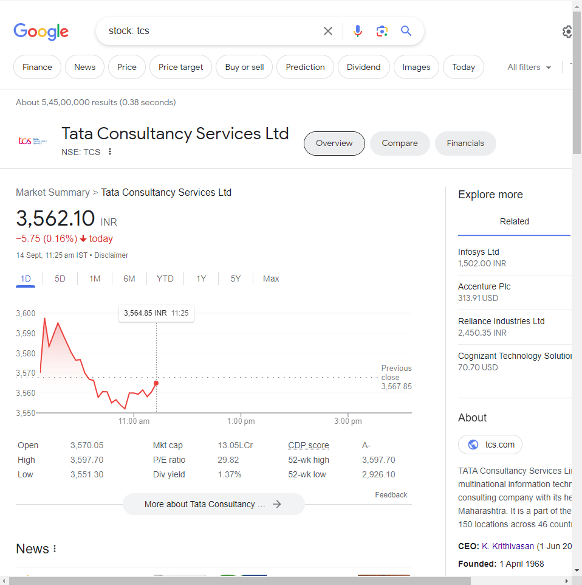

* 1. Show the current weather of Mumbai.

Command: weather mumbai

Output:

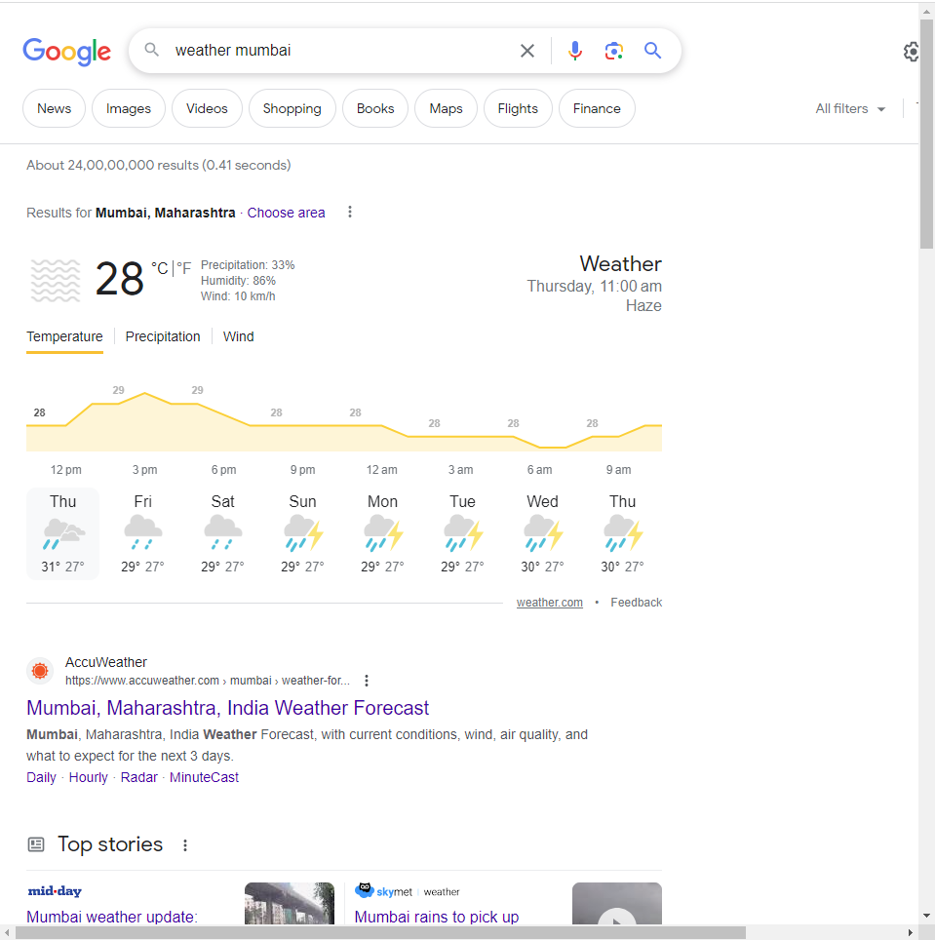

1. Give examples of the following operators:
   1. cache:

Command: cahce:www.irs.gov

Output:



* 1. info:

Command: info:www.theonion.com

Output:

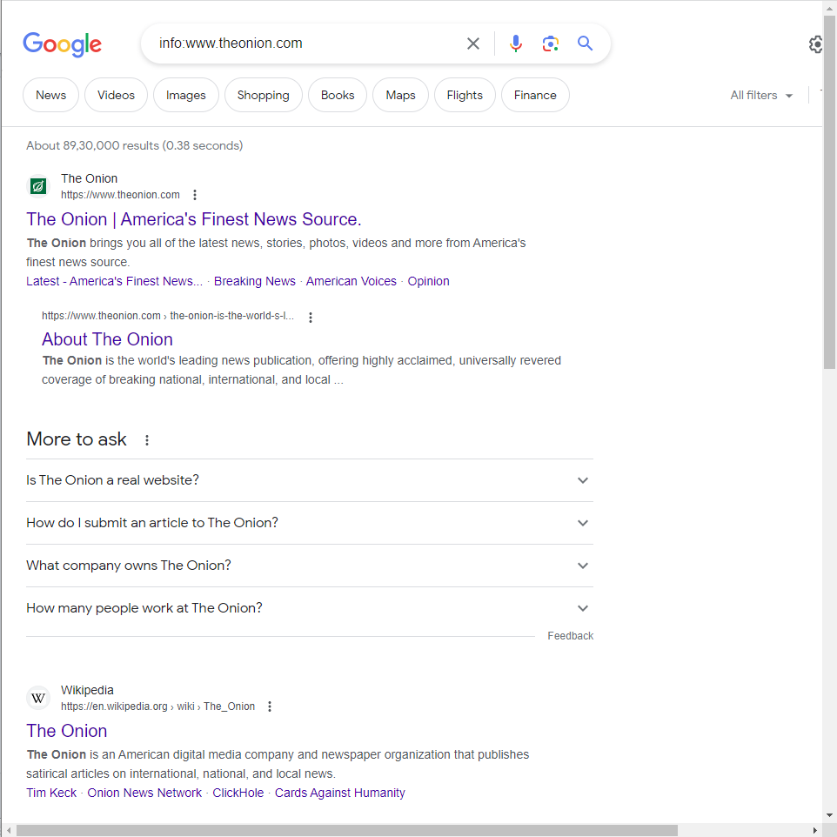

* 1. related:

Command: related: react.org

Output:

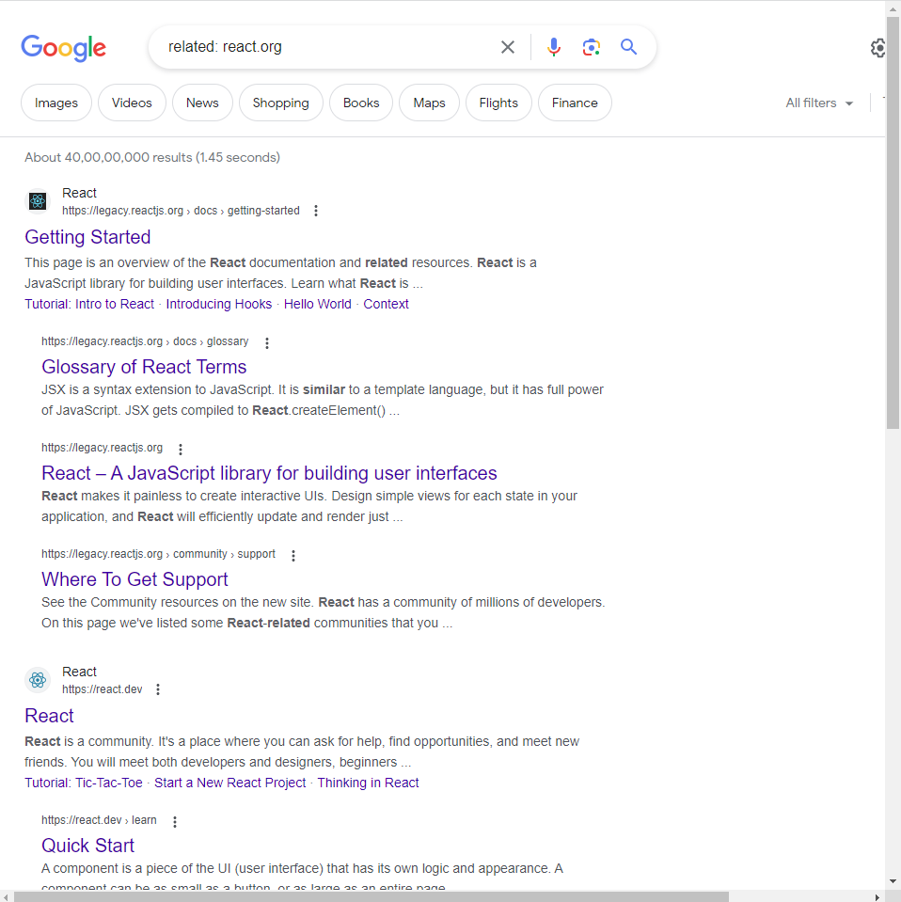

* 1. allinanchor:

Command: allinanchor: useful programming sites

Output:

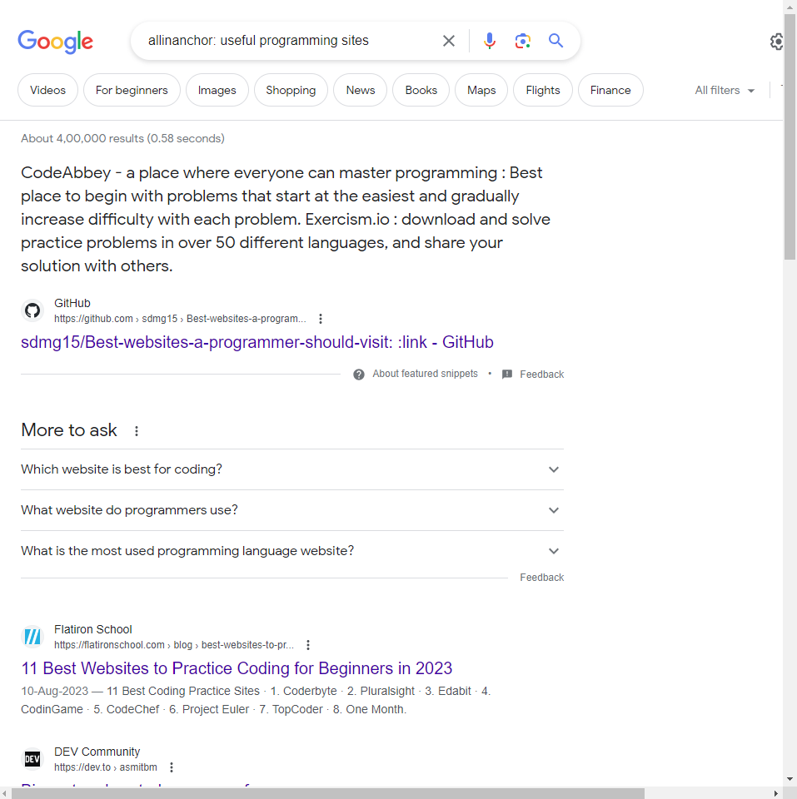

* 1. inanchor,allintext: ,intext: ,allintitle:,intitle: ,allinurl: ,inurl:

1. Restrict Search to Google Groups with author, group and in subject operators.
2. Restrict Search to Google News with operator’s location and source.